**Wireframe for depression Buster App**

* 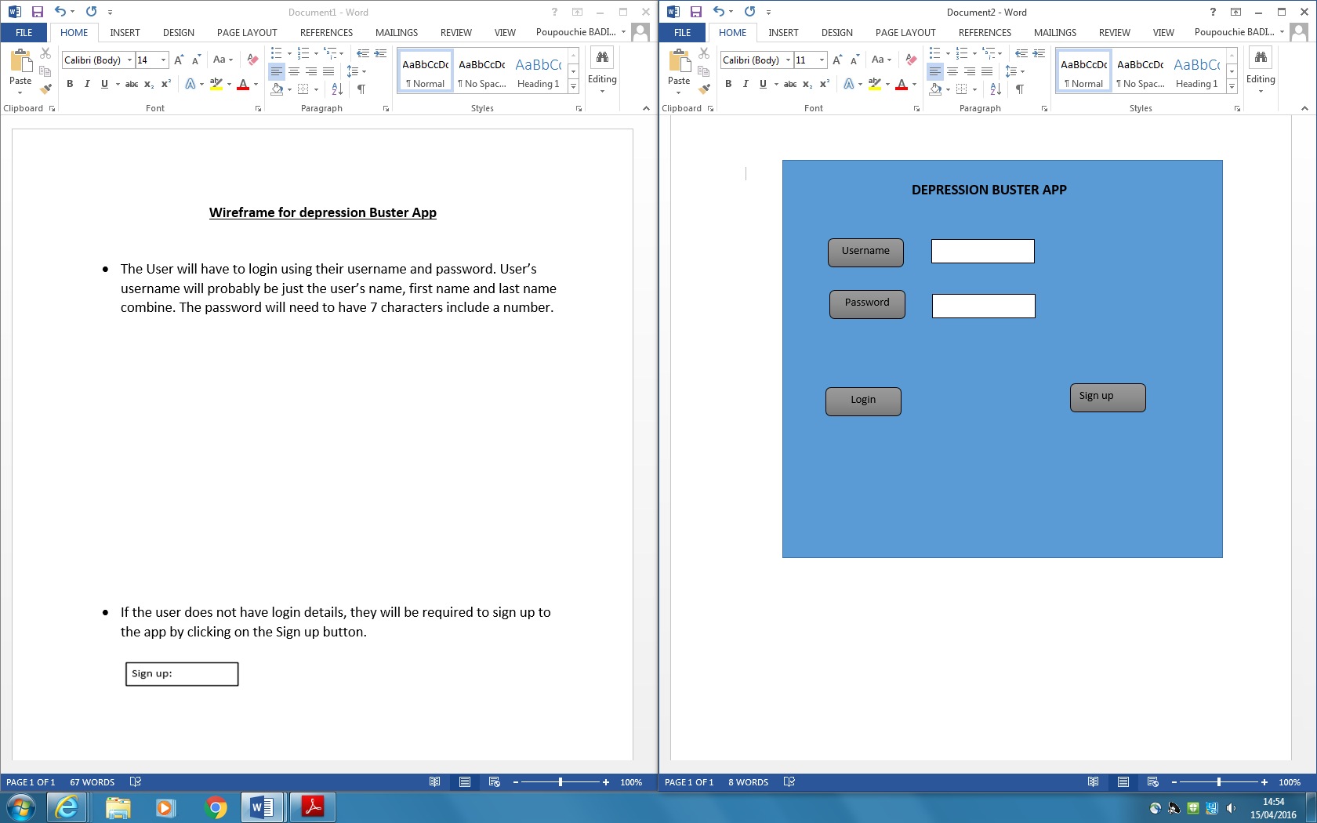The User will have to login using their username and password. User’s username will probably be just the user’s name, first name and last name combine. The password will need to have 7 characters include a number.
* 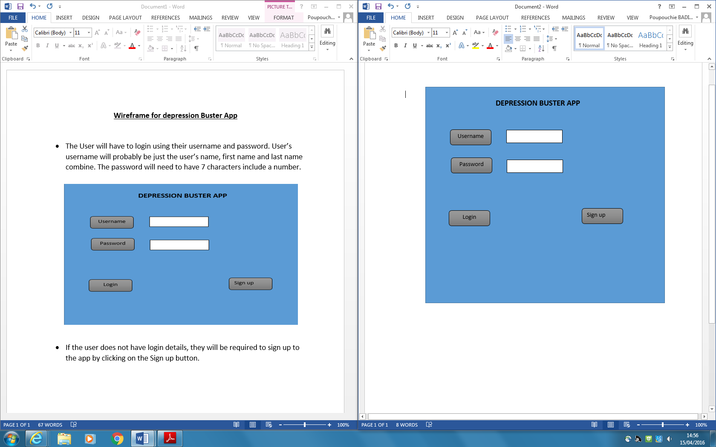If the user does not have login details, they will be required to sign up to the app by clicking on the Sign up button.
* After clicking on the sign up button, the registration page then come up and the user will have to fill in all the details on the registration page.

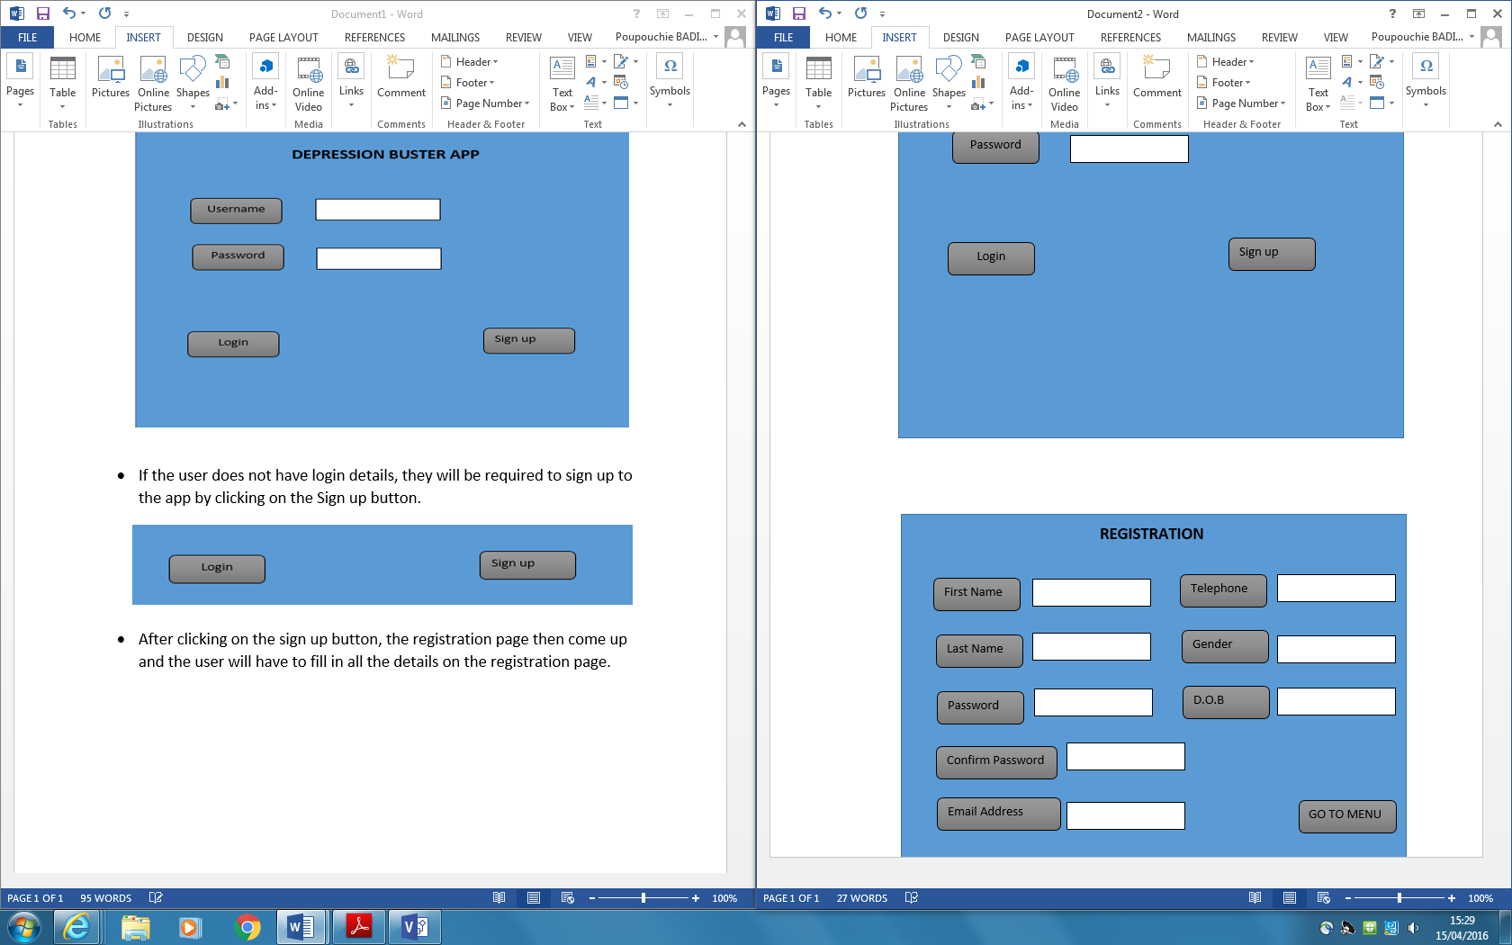

* When the user finishes the